THE REHAB ROOM.
Swimmer’s Shoulder!
By far and away the most common injury I see in swimmers is in the shoulder. So much so that it earns its own title of “Swimmer’s Shoulder”. Statistics vary however between 40-70% of all competitive swimmers will suffer this at some stage. It is usually caused due to too much total swimming load or an increase in loads too quickly beyond what the body can tolerate with a lack of recovery between sessions. Another common cause is a poor stroke technique. Considering that the arm will rotate over 1000 times in a 3.5km session we can see why poor technique may be a problem.
The shoulder is a ball and socket joint which allows for a good amount of mobility. Unfortunately the trade off is a decrease in stability. Therefore to help stability the shoulder requires good control of the ball in the socket largely due to well balanced rotator cuff and shoulder blade activity. Essentially, “swimmer’s shoulder” is an impingement (pinching) of the rotator cuff tendons. These tendons hold the ball of the arm (humeral head) into the socket (glenoid). The pinching occurs when there is a small loss of control of the ball in the socket and the tendons supporting it become jammed under the acromion (tip of shoulder blade). This then causes an irritation of the rotator cuff tendons causing pain and resultant reduction in function. Overload or overuse or poor technique as mentioned accelerates this process.
Common stroke faults leading to swimmers shoulder include:
- Insufficient body roll
- Entering water with thumb or index finger
- Crossing midline during pull phase
- Dropping elbow or arm too straight with pull phase
- Overreaching in stroke
- Lifting head to breathe
- Possibly the use of hand paddles with training

Common musculoskeletal faults or problems in the way the swimmer moves include:

- Stiff upper back and neck.
- Tightness in pectoral muscles (chest).
- Tightness in the shoulder capsule and muscles in back of shoulder.
- Weakness of external rotators (ideally internal to external rotator strength ratio is 1.5:1).
- Weak shoulder blade stabilisers.
- Weak core muscles.
- Poor muscle patterning (rotator cuff coupling – ie: how it functions).

As always prevention is better than cure therefore musculoskeletal screening of an athlete may be helpful to identify abnormal movement patterns and provide a prehab preventative programme to help address and rectify these abnormalities and theoretically prevent injury. A trained sports physiotherapist or health professional familiar with swimming injuries can do this.

Should shoulder pain arise it is best addressed sooner rather than later. Training volumes and recovery procedures need to be assessed. Stroke assessment and correction by your coach is also advisable. Ice therapy, and potentially anti-inflammatories as directed by your doctor can help relieve pain. Trigger point therapy with a spikey ball or foam roller to address tightness can also be useful. A rehab programme focussing on rotator cuff strengthening and scapula stability as well as stretching where indicated is also needed as suitable for the individual. If addressed early you may recover in 3-4 weeks, yet due to poor blood supply of the rotator cuff tendons a usual full recovery may take up to 2-4 months.

Happy racing!

David Garrick is an Australian trained titled Sports Physiotherapist working at Physio Central. He has a special interest in overuse sporting injuries particularly in runners, triathletes, football codes and skiers.
For further information email on david@physio-central.com or go to www.physio-central.com
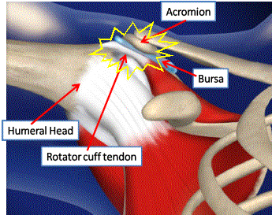 Swimmer’s Shoulder (rotator cuff pinching under acromion)
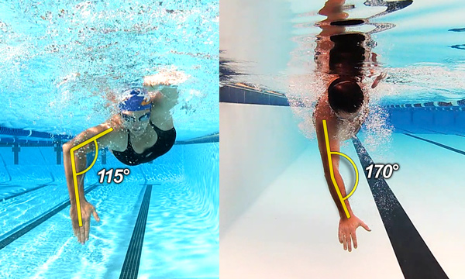Good (Left) vs Bad (Right) technique with elbow dropping
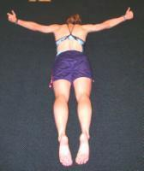 Scapula stability rehab exercise
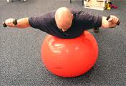Swim specific rotator cuff strengtheing exercise
Trigger point work in the pectoral muscles with a ball against a wall
Thoracic Spine foam rolling to improve mobility

